CN Practicals

1. Networking Commands :

Ping(Packet Internet Groper)

Ping is used to testing a network host capacity to interact with another host. Just enter the command Ping, followed by the target host’s name or IP address. The ping utilities seem to be the most common network tool. This is performed by [using the Internet Control Message Protocol](https://www.educba.com/internet-control-message-protocol/), which allows the echo packet to be sent to the destination host and a listening mechanism. If the destination host reply to the requesting host, that means the host is reachable.

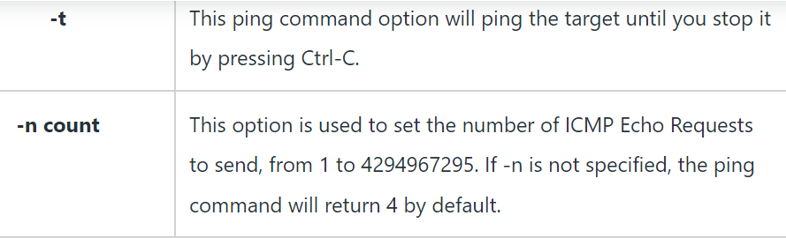

-c (number of packets) is used with ping to define the number of packets to be sent.

-i (time in seconds) is used to define the time interval between sending each packet.

NetStat(Network Statistics)

The netstat provides the statistics and information in the use of the current TCP-IP Connection network about the protocol.

Netstat command displays various network related information such as network connections, routing tables, interface statistics, masquerade connections, multicast memberships etc.

There are various options a user can use with the Netstat command.

Options are as follows-

-a : Show both listening and non-listening sockets. With the –interfaces option, show interfaces that are not up

-at : To list all tcp ports.

-au: To list all udp ports.

-l: To list only the listening ports.

-s : To list the statistics for all ports.

-r : Routing table information

Tracert

The tracert command is a [Command Prompt](https://www.educba.com/what-is-cmd/) command which is used to get the network packet being sent and received and the number of hops required for that packet to reach to target. This command can also be referred to as a traceroute. It provides several details about the path that a packet takes from the source to the specified destination.

The tracert command is available for the Command Prompt in all Windows operating systems.

The syntax for Tracert Command

tracert [-d] [-h MaxHops] [-w TimeOut]  target

There are various options the user can use with tracert command.

Options for tracert Command are as follows-

* target: This is the destination, either an IP address or hostname.
* –d: This option prevents Tracert from resolving IP addresses to hostnames to get faster results.
* -h MaxHops: This Tracert option specifies the maximum number of hops in the search for the target. If the MaxHops option is not specified the target has not been found by 30 hops, then the tracert command will stop looking.
* -w timeout: A timeout value must be specified while executing this ping command. It adjusts the amount of time in milliseconds.

#### Nslookup

The Nslookup, which stands for name server lookup command, is a network utility command used to obtain information about internet servers. It provides name server information for the DNS (Domain Name System), i.e. the default DNS server’s name and IP Address.

nslookup (stands for “Name Server Lookup”) is a useful command for getting information from the DNS server. It is a network administration tool for querying the Domain Name System (DNS) to obtain domain name or IP address mapping or any other specific DNS record. It is also used to troubleshoot DNS- related problems.

nslookup -type=any (IP) : Lookup for any record nslookup -type=a (IP) : Lookup for an a record nslookup -type=txt (IP) : Lookup for a txt record

arp

Theory: arp command manipulates the System’s ARP cache. It also allows a complete dump of the ARP cache. ARP stands for Address Resolution Protocol. The primary function of this protocol is to resolve the IP address of a system to its mac address, and hence it works between level 2(Data link layer) and level 3(Network layer).

-v: This option shows the verbose information.

-a: This option is used for showing entries of the specified host. If nothing is passed all entries will be displayed.

-n: This option shows numerical addresses instead of symbolic host, port or usernames

# Ifconfig

Theory: ifconfig (interface configuration) command is used to configure the kernel-resident network interfaces. It is used at the boot time to set up the interfaces as necessary. After that, it is usually used when needed during debugging or when you need system tuning. Also, this command is used to assign the IP address and netmask to an interface or to enable or disable a given interface. Here we have used it to find the IP and physical addresses of the computer, along with that we have used the following extensions:

-a : This option is used to display all the interfaces available, even if they are down.

-s : Display a short list, instead of details.

-v : Run the command in verbose mode – log more details about execution.

2. Framing Techniques

1. Character Count

// Character Count

#include<stdio.h>

#include<string.h>

int main(){

int n;

printf("Character Count \n");

printf("Enter the number of words you will enter : ");

scanf("%d", &n);

char a[n][15]; // Stores each word that can have a max size of 15 words each

int length[n]; // Stores the length of each word

for(int i = 0;i<n;i++){

scanf("%s", a[i]);

length[i] = strlen(a[i]);

}

for(int i = 0;i<n;i++){

printf("%d%s", length[i]+1, a[i]);

}

return 0;

}

1. Byte Stuffing